Notice
Date: 30/03/2024

It is hereby notified to all the students of the Philosophy Department that a special talk on “The Dharma and Philosophy in Culture in the light of Sri Aurobindo: In India and West”. Honourable Diganta Biswa Sarma will deliver the lecture as a resource person which will be held on 02/04/2024 at 12.30 PM.
Therefore, all the students of the Philosophy Department (Major/Minor/Honours/Generic) are asked to participate in the said programme without fail.

Venue: Conference Hall

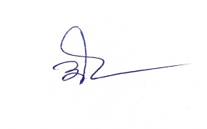
HoD, Philosophy

